AKHIL AUNGADH

XHAW5112 – Work intergrated learning

MILESTONE 1

ST10491477

**TABLE OF CONTENT**

REPORT……………………………………………………………………………………...3

MOTIVATION FOR DESIGN AND FUNCTIONALITY…………………………………...4

LOGO…………………………………………………………………………………………5

WIREFRAMES………………………………………………………………………………6

**Report of Web page and mobile application of Scenario**

It is recommended that Empowering the Nation wants to develop both a Website and a Mobile Application with identical functionality and a consistent user experience

The website will make the business accessible to a wider audience via search engines and desktop users while the mobile app will provide convenience and easy access for users who prefer mobile devices. By having both platforms Empowering the Nation can reach employers, Domestic workers and Gardeners more effectively.

The recommended features are :

Home page – showcasing the logo, Business purpose and links to course information

Course Summaries and Details – Separate pages for screens for six-month and six-week courses, each linking to detailed course descriptions and fees.

Fee Calculator – Allowing users to select one or more courses and automatically apply discounts, add VAT and generate a quoted total.

Contact Page – Displaying phone number, email and physical addresses of training venues in Johannesburg with interactive maps.

Consistent Navigation – Drop down menus and back buttons across all pages and screens to improve usability.

User Forms – Contact forms that validate inputs (e.g. correct phone number and email format) and allow customers to request a call back or quotation.

The design will use:

Professional fonts and colour scheme (green for growth, blue for trust, orange for energy).

• Icons and simple layouts for intuitive navigation.

• A logo that reflects empowerment, growth, and learning.

By implementing this recommendation, Empowering the Nation will:

• Build a professional digital presence.

• Make course information clear and accessible.

• Improve customer engagement through the fee calculator and enquiry forms.

• Strengthen its brand identity with a meaningful logo and consistent design.

• Ensure inclusivity by making the platform easy to use for both employers and community members.

**Motivation for Design and functionality**

The design of the website and mobile application has been chosen to reflect professionalism, accessibility and empowerment which are central to Empowering the Nation’s mission. The clean layout, modern fonts and colour scheme (green for growth, blue for trust and orange for energy) were selected to create a professional yet approachable image. A simple but yet eye-catching logo ensures that the brand is easily recognisable across both platforms.

The functionality incorporated into both the website and mobile app is based directly on the needs of the business and its users. The course summaries and detail pages make it easy for customers to browse available programmes and understand fees and content before making decisions. The fee calculator is a key feature that adds value to customers by providing instant transparency on pricing, applying discounts for multiple course selections, and including VAT. This builds trust and encourages customers to request quotations.

The inclusion of a contact page with phone, email and venue addresses (with maps) ensures that customers can easily connect with Empowering the Nation and locate the nearest training centre. Navigation has been designed with drop down menus, icons and back buttons, so even users with limited technical skills can comfortably move through the system. Error handling within forms further improves reliability by ensuring that customer details are entered correctly.

By incorporating these features into both the website and mobile app, Empowering the Nation can provide a consistent, user friendly experience across devices. This approach not only enhances accessibility for domestic workers and gardeners but also appeals to employers who value professionalism and clarity when enrolling their staff. Ultimately the design and functionality ensure that the platform supports the organisation’s goal of empowering individuals through skills training while presenting a credible, trustworthy digital presence.

**LOGO**



**WIREFRAMES**

Link :

<https://www.figma.com/design/Q27YxUTuayXA0yZ3OuZ51B/MOBILE-APP-DESIGN-EPTN?node-id=0-1&t=LEKyPPQMSLoK3tTL-1>

PNG of Wireframe Mobile App

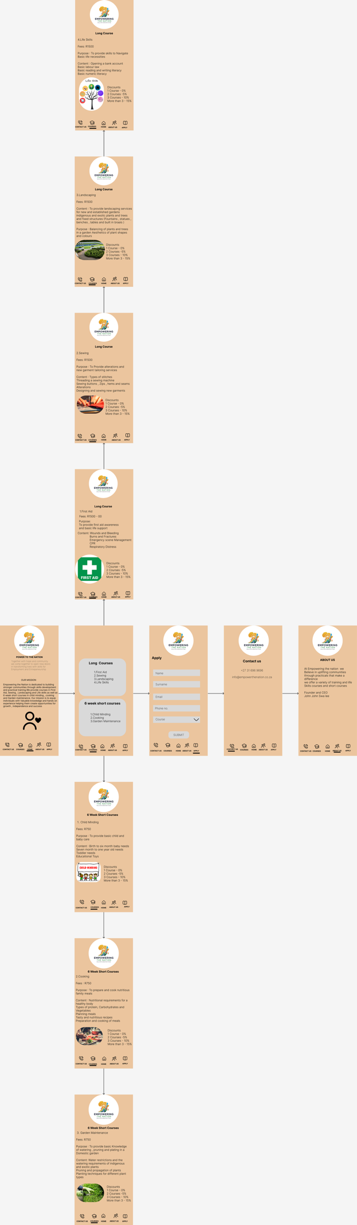

**Website Wireframes**

<https://www.figma.com/design/0VJDUeh2AOv2FKcn1C88ac/Untitled?node-id=0-1&t=UD6YAYqezSXsLwKc-1>

PNG of website wireframes

